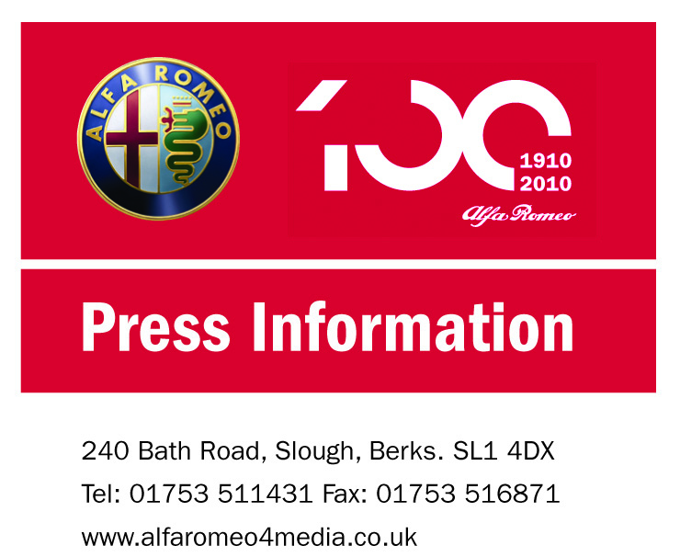

FOR IMMEDIATE RELEASE
12 August 2010

ALFA MITO TURISMO SPORT JOINS THE RANKS FROM

£199 A MONTH OTR

Alfa Romeo UK is welcoming a new special edition version of the sporty compact Alfa MiTo to its showrooms this month. Brimming with additional content and available from just £199 a month with a £1,000 deposit, the Alfa MiTo has never been so enticingly accessible.

The new Alfa MiTo Turismo Sport combines head-turning design, dynamic performance and engineering technology with an additional £1,610 worth of optional equipment – all from just £12,895 OTR.

To add to an already attractive package, customers can also take advantage of Alfa’s latest finance deal that delivers the MiTo Turismo Sport 1.4 16V 95bhp from just £199 a month with only a £1,000 deposit required.

The new sporting edition will be available in a choice of three visually arresting colours –Solid Black (as standard), Biancospino White or the new Alfa Metallic Red.

more…

Alfa MiTo Turismo Sport joins the ranks from £199 a month OTR..2

There is further choice to be had when it comes to engine power for the MiTo Turismo Sport.

The sprightly 1.4 16V 95bhp petrol version available from £12,895 OTR is joined by the acclaimed 1.3 JTDM-2 95bhp MultiJet turbodiesel, which is available from £14,410 (£219 a month with a £1000 deposit).

While the 95bhp 16V petrol engine provides a fun and engaging drive, the advanced second generation MultiJet turbodiesel engine − JTDM-2 − perfectly complements the Alfa MiTo philosophy of low emissions (112g/km of CO₂) and fuel consumption (65.7mpg on the combined cycle) without compromising performance and driver satisfaction (0-62mph in 11.6 seconds).

On top of the already impressive standard equipment found in the MiTo Turismo; such as air conditioning and state-of-the-art Alfa D.N.A technology, the Alfa MiTo Turismo Sport special edition includes 16” alloy wheels, rear spoiler, cruise control, Blue & Me™ technology, fog lights and a leather steering wheel incorporating audio and phone controls.

To find out more about the new MiTo Turismo Sport or to test drive any new Alfa Romeo model, customers should visit www.alfaromeo.co.uk

– ENDS –

more…
Alfa MiTo Turismo Sport joins the ranks from £199 a month OTR..3

Sample Finance Option

Model Turismo Sport 1.4 16V 95bhp in Solid Black
OTR £12,895
Deposit £1,000
Number of monthly payments 47
Monthly payments £199
Optional Final payment (excl fees) £4,154
APR Typical 5.9%

Model Turismo Sport 1.3 JTDM-2 95bhp in Solid Black
OTR £14,410.00
Deposit £1,000.00
Number of monthly payments 47
Monthly Payments £219.00
Optional Final Payment (excl fees) £4,655.00
APR Typical 5.0%

FOR FURTHER INFORMATION

Head office contacts:
Ross Milton, Press Officer on 01753 571717 or email ross.milton@alfaromeo.com or Anna Angelini, PR Manager, Alfa Romeo UK on 01753 571717 or email anna.angelini@alfaromeo.com or Peter Newton, PR Director, Fiat Group Automobiles UK Ltd on 01753 511431 or email peter.newton@fiat.com

61417/120810

