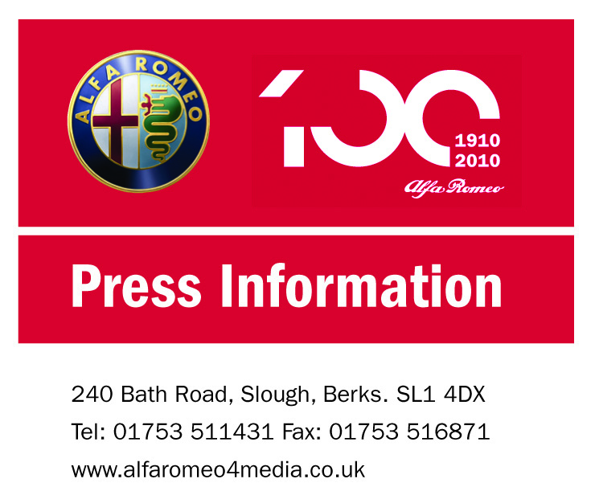
FOR IMMEDIATE RELEASE

18 November 2010

Alfa MiTo wins Best Supermini in
What Car? Reader Awards 2010

Stylish, sporty and now award winning, the Alfa MiTo has finished top of its class in the What Car? Reader Awards 2010.

As the only annual car awards voted for solely by the car buyer, What Car? Reader Awards indicate who the real world automotive winners are in 2010, and Alfa Romeo is delighted to receive the Reader Award for Best Supermini for the sporty, compact Alfa MiTo from its most important critics, owners and potential customers.

With an average star reader rating of 4.6 out of five, the Alfa MiTo not only topped the supermini category but came third overall in the Best Car segment, ahead of 167 competitors. In the Best Manufacturer category Alfa Romeo came an impressive fourth out of 30 manufacturers, with an average star reader rating of 4.3 out of five.

In the supermini class, the MiTo was joined by other Fiat Group Automobiles models, the Fiat 500 and Fiat Panda in second and third place respectively – stamping an all Italian authority on one of the most hotly-contested segments of the UK automotive market.

more…

Alfa MiTo wins Best Supermini in What Car? Reader Awards 2010…2

Launched in the UK in 2009, the Alfa MiTo introduced a new era to the B segment, offering a true alternative to its mainstream competitors. This was made possible by the introduction of a host of new technologies, including Alfa Romeo’s dynamic control system, known as DNA, and award winning MultiAir engine technology; a five star Euro NCAP safety rating; and a competitive price tag for a car with head turning good looks, individualism and sporty credentials. These key attributes were reflected in What Car? readers’ reviews.

Brand Communications Manager of Alfa Romeo UK, Damien Dally says: “For us to receive this award thanks to the excellent feedback What Car? has received about the MiTo from its readers, is fantastic. It truly affirms MiTo’s place as a strong, viable and credible option for people looking for a sporty yet practical compact car.

“In addition, as a manufacturer we’ve continued to invest a great deal in improving all aspects of the Alfa Romeo experience, and today, in 2010, we have a dealer network which is moving in the right direction, a product range including the MiTo and all-new Giulietta whose quality matches their looks, and residual values which now position our cars as head, as well as heart, purchases.”

For more information on the award winning Alfa MiTo and the rest of the Alfa Romeo range visit www.alfaromeo.co.uk

- ENDS –

Head office contacts:
Ross Milton, Press Officer on 01753 571717 or email ross.milton@alfaromeo.com or Anna Angelini, PR Manager, Alfa Romeo UK on 01753 571717 or email anna.angelini@alfaromeo.com or Peter Newton, PR Director, Fiat Group Automobiles UK Ltd on 01753 511431 or email peter.newton@fiat.com

